**HCI**

**ASSIGNMENT #4**

**Human-Computer Interaction**

**STUDENT REGISTRATION SYSTEM**

**Members:**

Amna Mubarak 20k-1695

Ehtesham Zafar 20k-1655

Hassan Ali 20k-1052

**Interaction Styles**

1. command line interface
2. three-dimensional interfaces

* **Menus:**

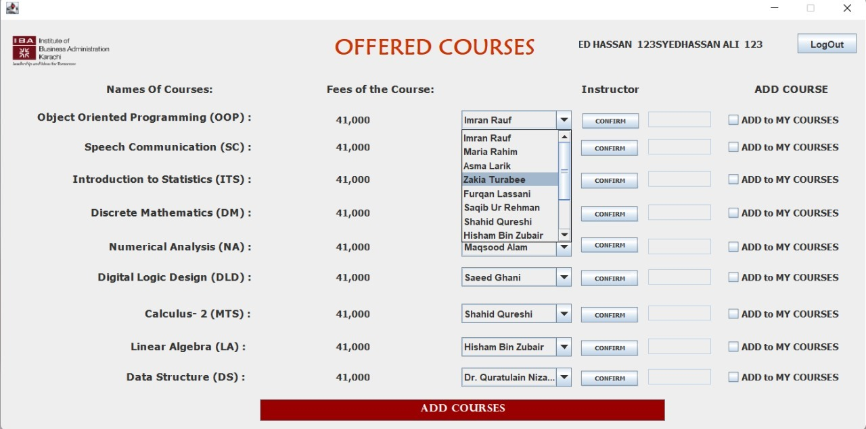

Menus are the options that are displayed on the screen often in a form of groups. On this screen, there is a drop-down menu that lists all the lecturers of different courses. Users can select their preferred lecturers from here.

* **Natural Language**

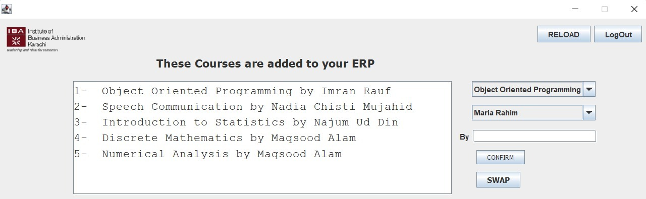

In the above screenshot, there are two buttons to RELOAD and Logout which are both stated in Natural Languages. This will help the user to understand the functionalities of these buttons.

Along with that, the white dialog box shows the courses with respect to their lecturers in humanly language.

* **Question/Answer and Query Dialog**

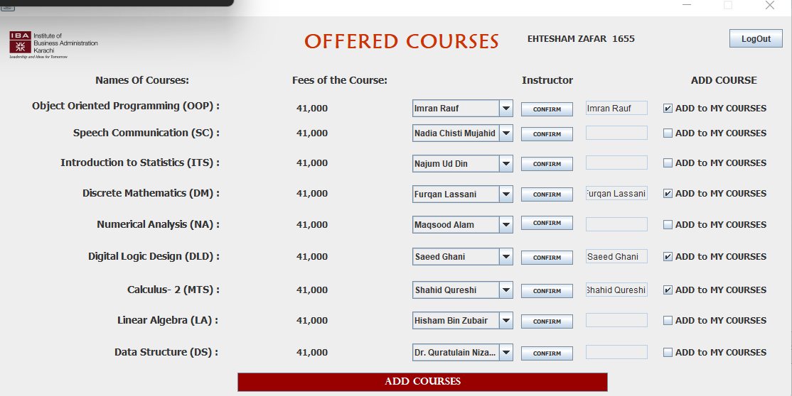

In the above screenshot, the user is asked to fill this Question/ Query box with multiple answers which are provided in the form of menus. The user will select lectures and then click on CONFIRM to add the course in his semester.

* **Form-fills and Spreadsheets**

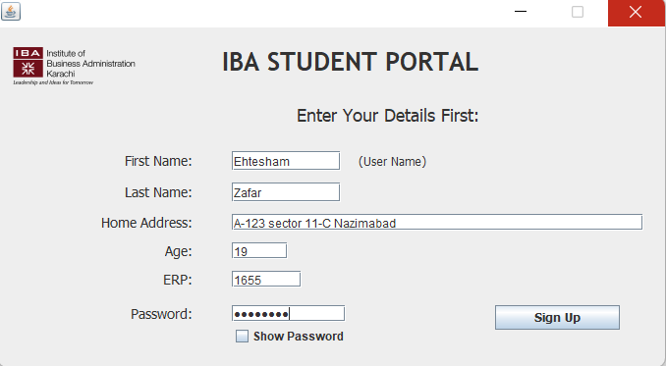

This is the signup screen of our Student Registration System. Here the user has to fill this form by providing his personal details.

* **WIMP**

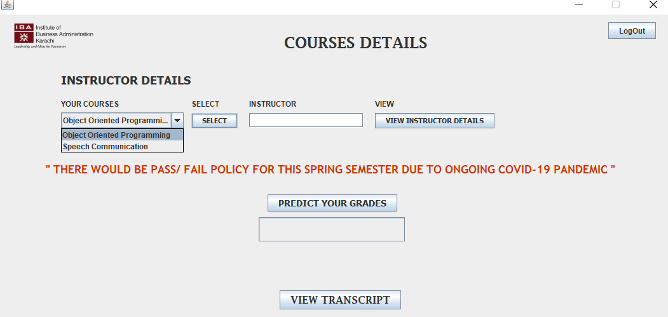

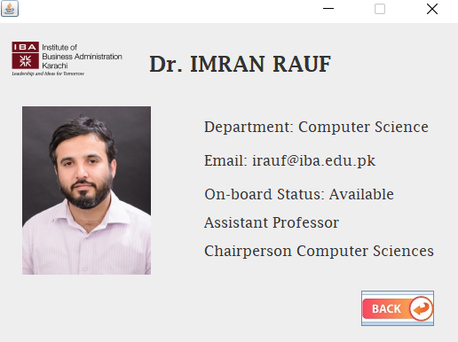

WIMP stands for Windows, Icon, Menu and Pointer, our interface has all of these interaction styles. We have implemented a back icon that will help the user to go back. Moreover, our interfaces have multiple menus. It also highlights the button when the mouse pointer hovers over it.

* **Point and Click**

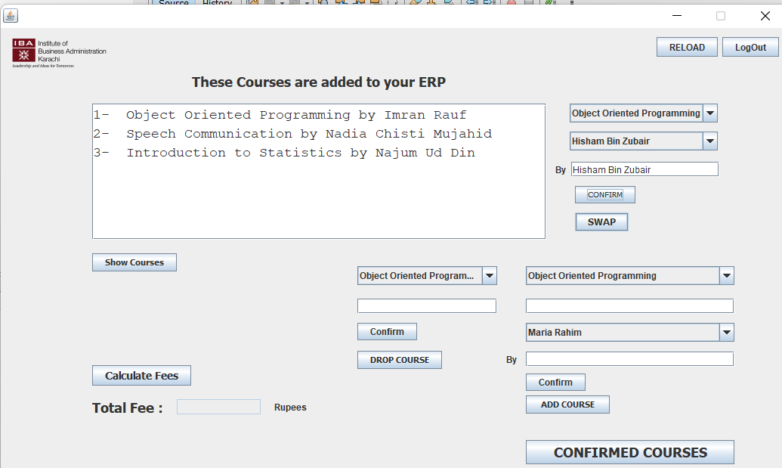

When we move our mouse pointer to any button of icon, it highlights that particular button which indicated that the mouse pointer is hovering over it. Like here we are pointing to **confirm** button.